**Dynamic HTML (DHTML)**

* **Definition**: DHTML refers to the combination of technologies like HTML, CSS, JavaScript, and DOM that allows web pages to be interactive and dynamic. Unlike static HTML, DHTML enables real-time changes to content, structure, and style without requiring a page reload.

**Document Object Model (DOM)**

* **Definition**: DOM is a programming interface that represents HTML or XML documents as objects, allowing scripts to dynamically access, manipulate, and modify the document's structure, style, and content.
* **Structure**: The document is structured as a tree (nodes). Each HTML element is represented as a node that can be manipulated.

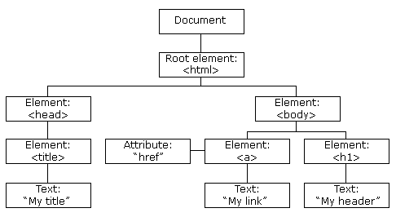

**Features of DHTML**

1. **Dynamic Content**: Content of a web page can be changed on the fly without reloading.
2. **Real-Time Style Changes**: CSS allows real-time modification of styles such as color, size, and positioning.
3. **Event-Driven**: Allows interaction through events like mouse clicks, key presses, and page load actions.
4. **Animation**: Elements can be animated with transitions, movement, or other visual effects using JavaScript.

**Cascading Style Sheet Positioning (CSSP)**

* **Definition**: CSSP allows you to control the position of HTML elements on a web page. You can specify exact positioning (absolute or relative) using CSS properties.
* **Types of Positioning**:
  1. **Static**: Default positioning; elements appear in the normal document flow.
  2. **Relative**: Positioned relative to its normal position.
  3. **Absolute**: Positioned relative to the nearest positioned ancestor, or the document body.
  4. **Fixed**: Positioned relative to the browser window, stays in place when scrolling.
  5. **Z-index**: Controls the stack order of elements (which elements appear on top).

**JavaScript-Assisted Style Sheet (JSSS)**

* **Definition**: JSSS is an outdated technique where JavaScript is used to dynamically modify or apply CSS styles on the fly. It predates the modern CSS manipulations but served as a way to provide more interaction to web pages.

**Layers in Netscape**

* **Definition**: In early versions of Netscape browsers, the concept of "layers" was introduced to manage multiple content areas on a page. Layers allowed content to be stacked and manipulated separately, similar to CSS positioning but specific to Netscape.
* **Usage**: Layers were an important feature for dynamically positioning content, but they were eventually replaced by more standardized methods like div elements and CSS positioning.

**The ID Attribute**

* **Definition**: The id attribute is a unique identifier for an HTML element. It is used to reference a specific element in CSS and JavaScript for styling or manipulation.
* **Example**:

**html**

<div id="myDiv">Content</div>

This allows for easy manipulation of the element in both CSS and JavaScript:

**css**

#myDiv { color: blue; }

javascript

Copy code

document.getElementById('myDiv').innerHTML = "New Content";

**DHTML Events**

* **Definition**: Events in DHTML are actions triggered by user interactions or browser actions. Events can be handled using JavaScript to make web pages interactive.
* **Common DHTML Events**:
  1. **onClick**: Triggered when an element is clicked.
  2. **onMouseOver**: Triggered when the mouse pointer moves over an element.
  3. **onLoad**: Triggered when the web page is completely loaded.
  4. **onFocus**: Triggered when an element gains focus.
  5. **onKeyPress**: Triggered when a key is pressed on the keyboard.
* **Event Handling**: JavaScript is typically used to handle events and can dynamically change content or style based on user actions.

**Deep Dive Example**

To demonstrate the use of DHTML, consider a simple example where a button click changes the content of a div and its style:

**html**

<!DOCTYPE html>

<html>

<head>

<style>

#dynamicDiv {

width: 100px;

height: 100px;

background-color: red;

position: relative;

}

</style>

<script>

function changeContent() {

var div = document.getElementById('dynamicDiv');

div.innerHTML = "New Content!";

div.style.backgroundColor = "blue";

}

</script>

</head>

<body>

<div id="dynamicDiv">Old Content</div>

<button onclick="changeContent()">Click Me</button>

</body>

</html>

This example demonstrates dynamic content and style manipulation using DHTML principles.